### Multivariate Linear Regression:

#### Full Dataset

|  | Train | Test |
| --- | --- | --- |
| RMSE | [8.4205404, 6.47196987] | [8.25813787, 6.53287661] |
| MAE | [5.73713227, 4.3361085] | [5.76408362, 4.44876215] |
| y-intercept | [ 4.50313219, -1.8351527 ] | |

Train Prediction vs Truth of dbn and dbe values (red: predict, blue: truth):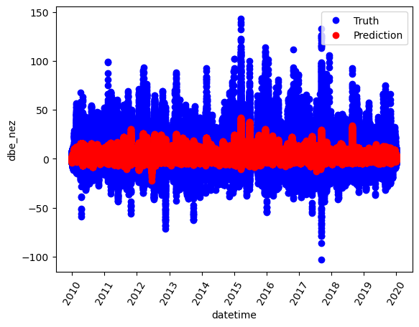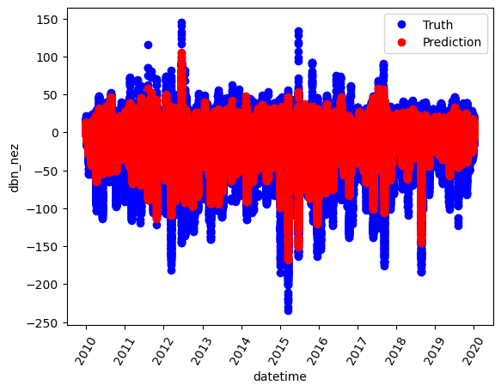

Test Prediction vs Truth (red: predict, blue: truth):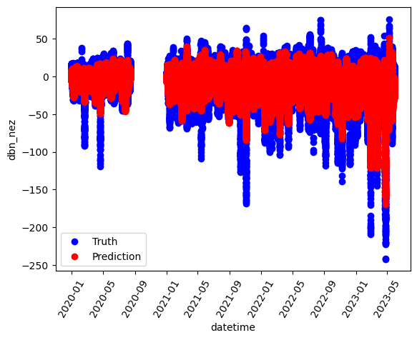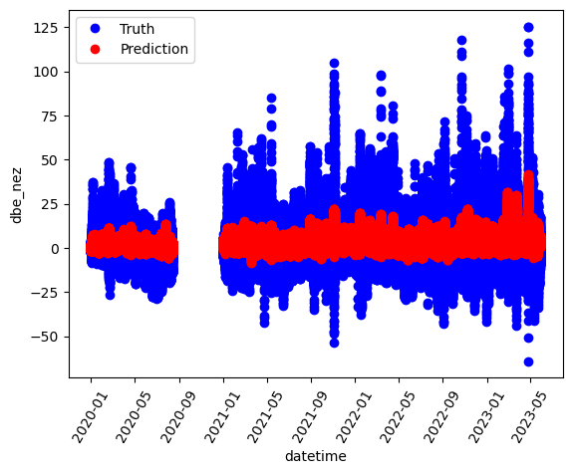

#### 2 Days Data:

* + Training data: 03/17/2015 - 03/18/205
  + Test data: 04/23/2023 - 04/24/2023

|  | Train | Test |
| --- | --- | --- |
| RMSE | [35.45392765, 29.3539302] | [23.21145614, 25.3229549] |
| MAE | [23.49954339, 20.39394877] | [17.44651138, 15.70419005] |
| y-intercept | [ 4.50313219, -1.8351527 ] | |

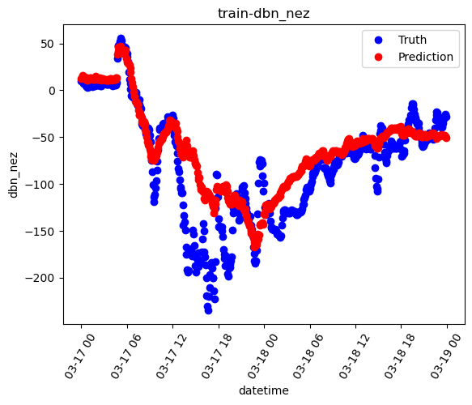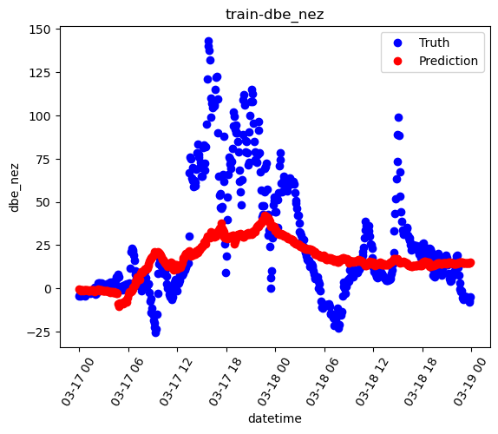

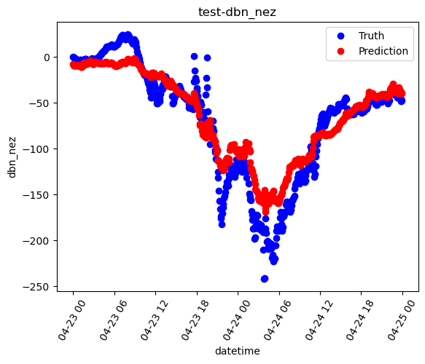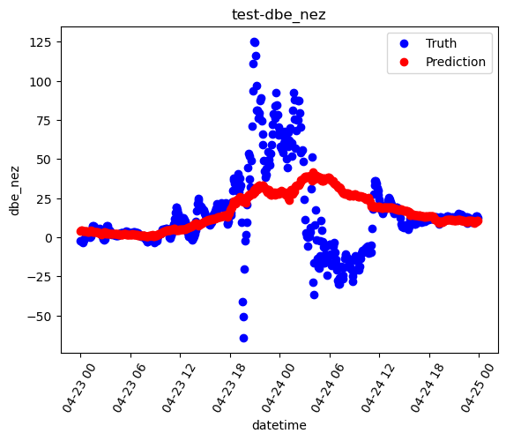

#### 5 hours data:

* + Training data: 13:00 - 18:00 (03/17/2015)
  + Test data: 01:00 - 06:00 (04/24/2023)

|  | Train | Test |
| --- | --- | --- |
| RMSE | [85.42463006, 57.29418204] | [46.45776617, 42.68058309] |
| MAE | [79.63336256, 49.53712127] | [42.93471381, 39.74226212] |
| y-intercept | [ 4.50313219, -1.8351527 ] | |

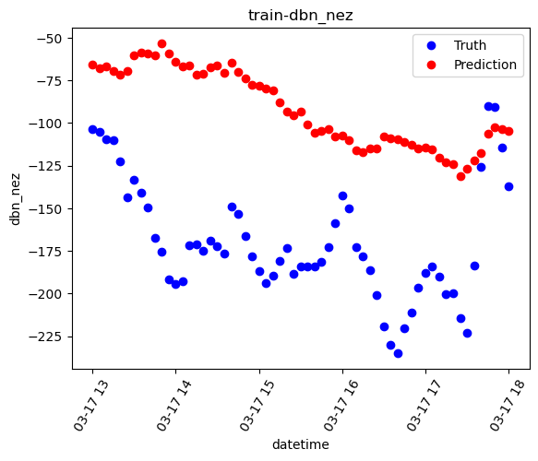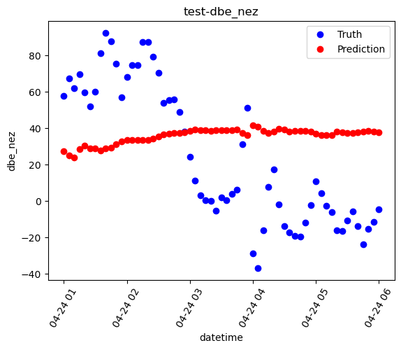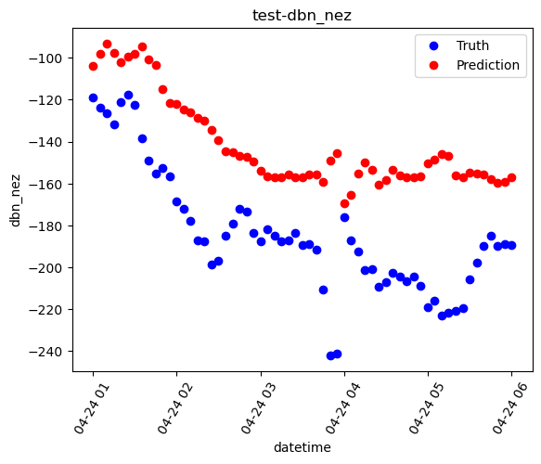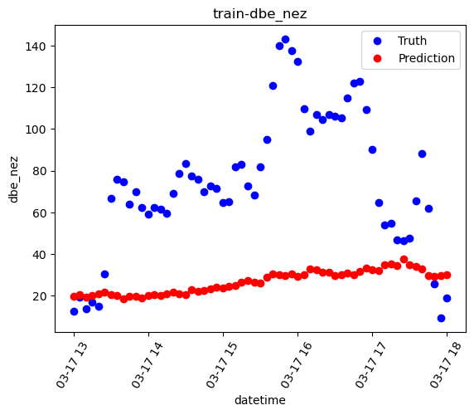

### Regression Random Forest:

#### Full dataset

|  | Train | Test |
| --- | --- | --- |
| RMSE | [1.25627031, 1.08539726] | [8.0079362, 6.12816096] |
| MAE | [0.75129223, 0.64139433] | [5.63303709, 4.21504891] |

Train Prediction vs Truth of dbn and dbe values (red: predict, blue: truth):

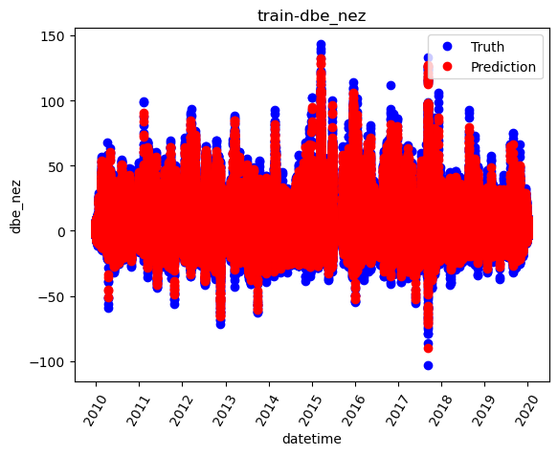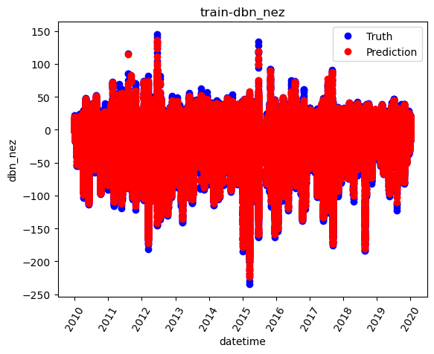

Test Prediction vs Truth (red: predict, blue: truth):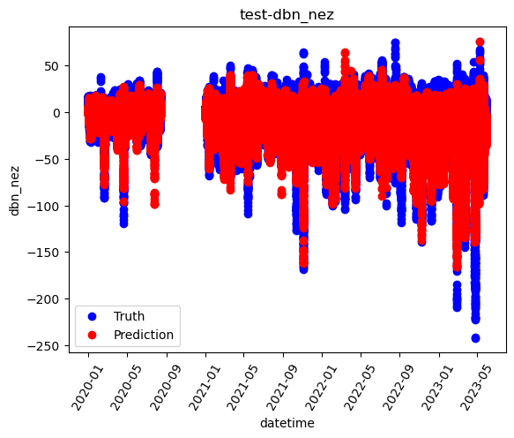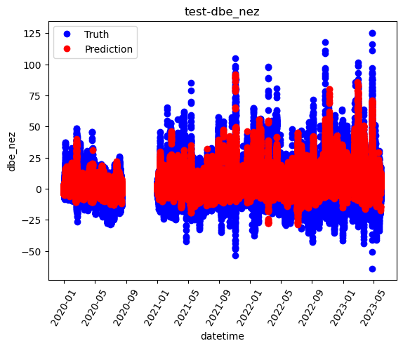

#### 2 Days Data:

* + Training data: 03/17/2015 - 03/18/205
  + Test data: 04/23/2023 - 04/24/2023

|  | Train | Test |
| --- | --- | --- |
| RMSE | [3.70596721, 3.46329413] | [30.21598026, 25.29522474] |
| MAE | [2.34339385, 2.21563712] | [21.74424072, 16.89182685] |
| y-intercept | [ 4.50313219, -1.8351527 ] | |

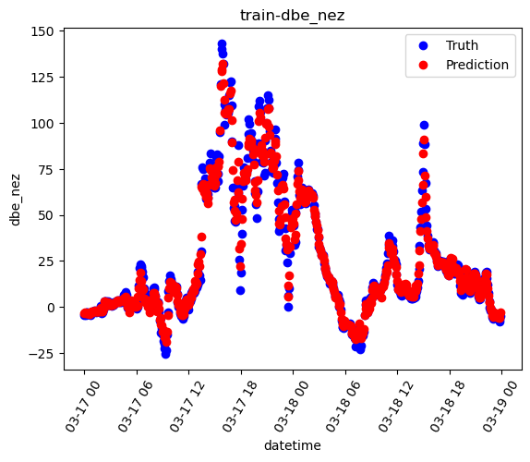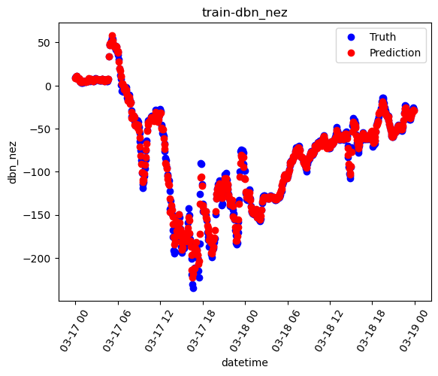

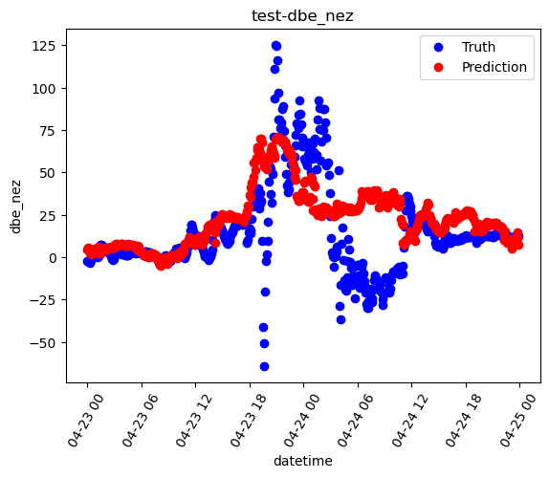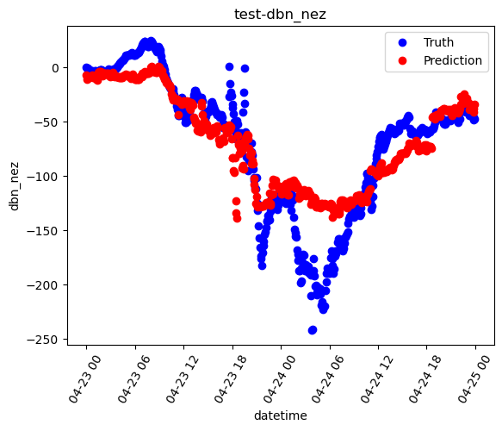

#### 5 hours data:

* + Training data: 13:00 - 18:00 (03/17/2015)
  + Test data: 01:00 - 06:00 (04/24/2023)

|  | Train | Test |
| --- | --- | --- |
| RMSE | [8.01684948, 6.46046939] | [69.50483959, 37.74589946] |
| MAE | [6.27515247, 5.03847867] | [65.31323653, 34.86787135] |

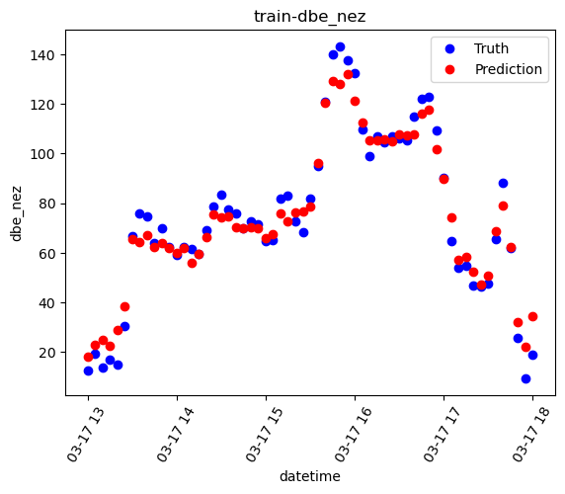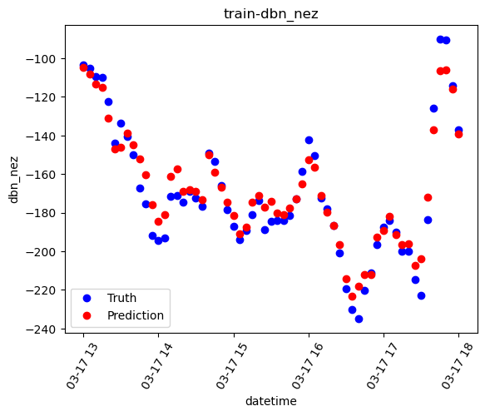

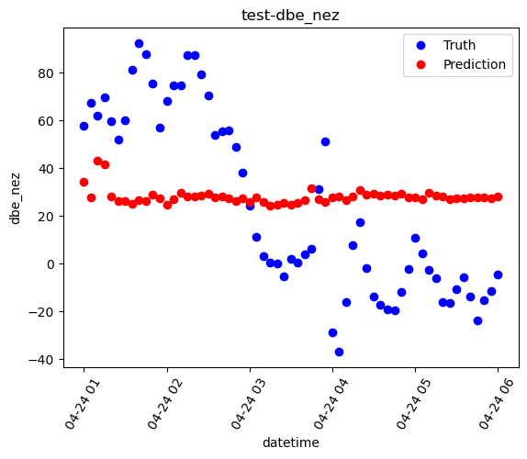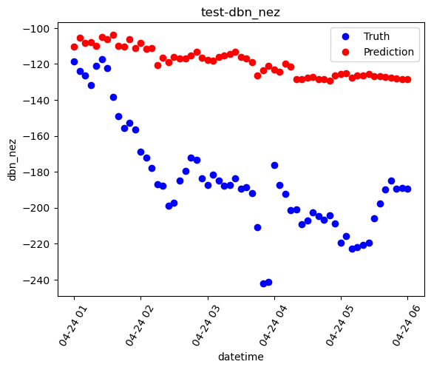

### Analysis Part:

* **Plotting (dbn, dbe) as scatter plot point on the plane**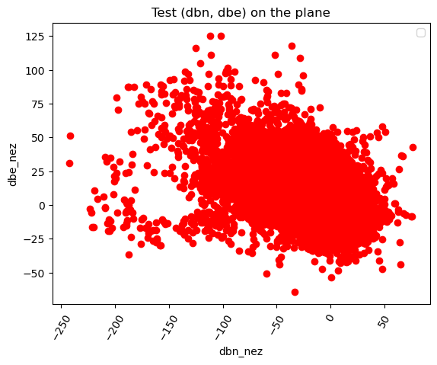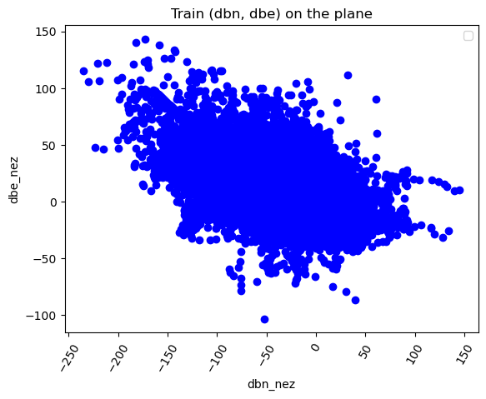
* **Corner plots of input features:**



* + <https://drive.google.com/file/d/18QpAvBXr11QNdLvcE7L2n1puiCCdW2Wn/view?usp=drive_link>



* + <https://drive.google.com/file/d/1i2a-0amE3K7XUh3R32qbUSmvzzP4nync/view?usp=sharing>

### **Random Forest Hyperparameter Optimizations**

#### **Results of Best Hyperparameter From RandomSearchCV.**

##### **Full Dataset**

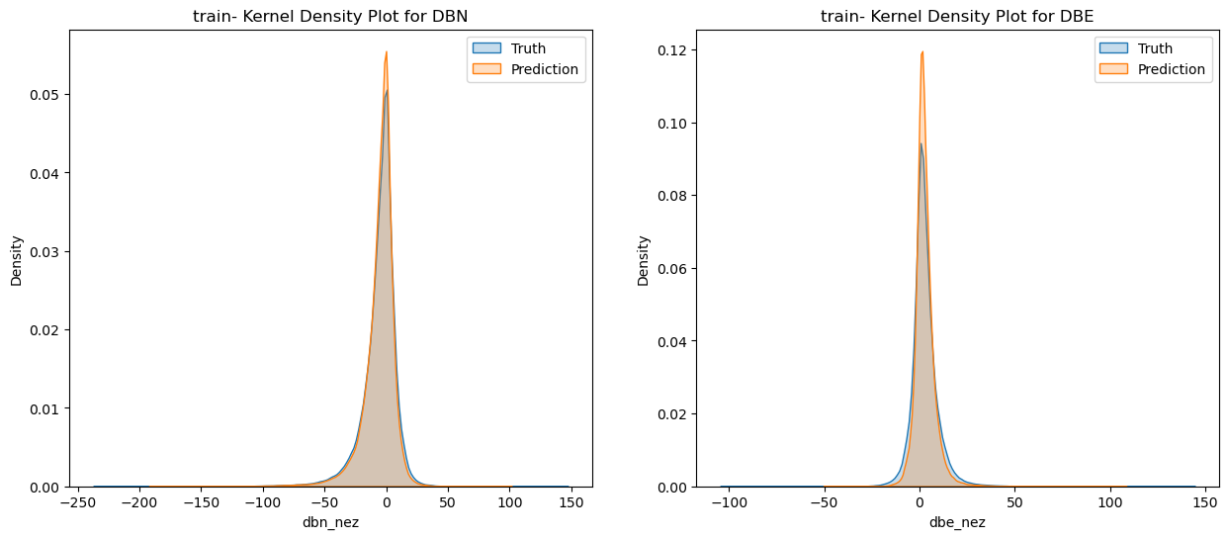

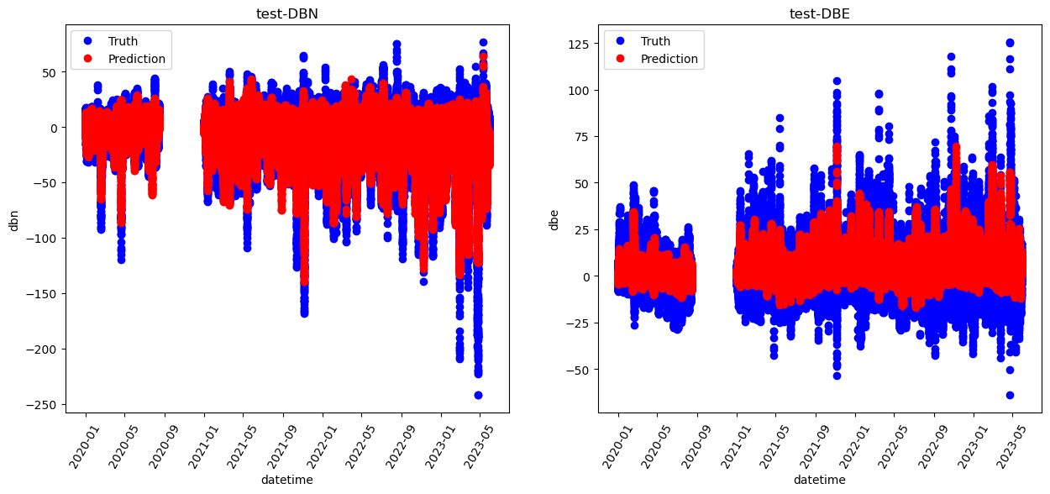

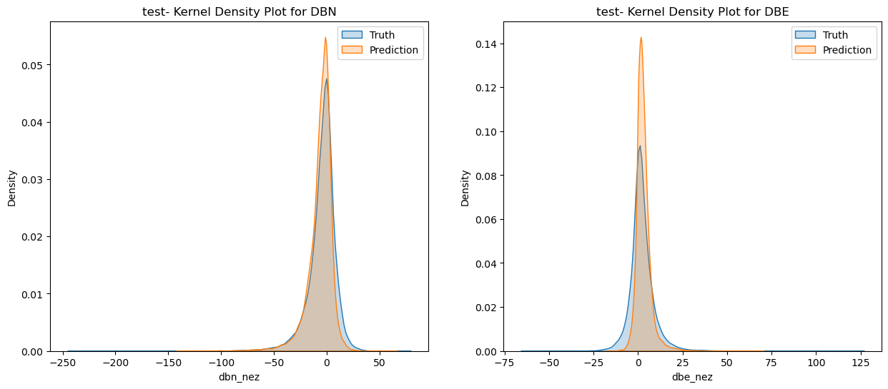

##### **Two Days Dataset**

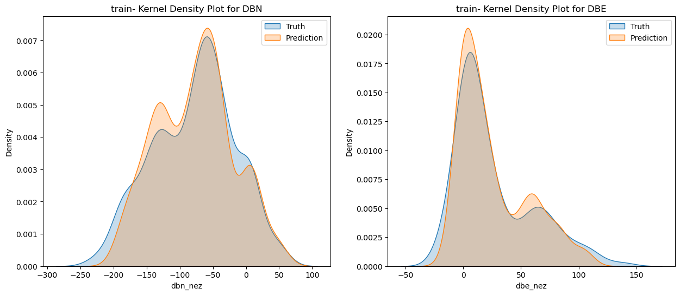

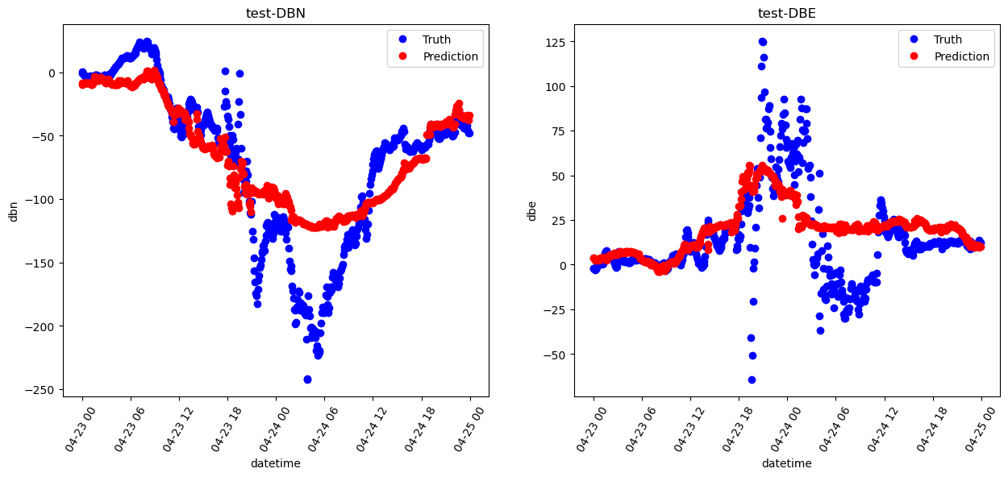

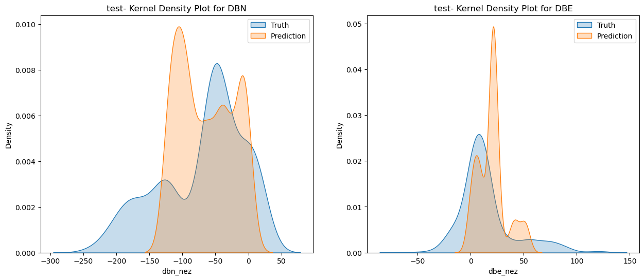

##### Few Hours Data

